**CIS 3400, Group 5, Project Report**

**Project Overview:**

Valentino Bugel, a small fashion company located in Manhattan was in need of a platform that allowed the company to receive orders and track sales. As an alternative to the system already in place of handwritten folders a database was created in order to ease and quicken the task of data entry and modification of sales records for each entity. The database is designed to collect information regarding demand for its styles, in order to deliver highly demanded designs in its new collection. Additionally the database will allow Valentino Bugel to have a menu driven platform for entry and report viewing of sales orders, purchase orders, sales representatives. Overall the database should improve the efficiency of Valentino Bugel’s process of sales and manufacturer orders. In the database manufacturers are called vendors.

In order to achieve that the highly demanded designs make it to production on time for the new collection a series of exchange of information has to occur. In this situation the amount of production has to be calculated based on the orders placed, which indicate the level of demand, in the stores which are later collected by sales representatives. The collected orders are sent to Valentino Bugel’s headquarters, there they are segregated into sets. Each set of orders is later sent to a specific manufacturer.  With this new database Valentino Bugel is able to deliver its highly demanded designs quicker to its manufacturers and therefore quicker to its customers.

**ER Diagram and Normalization:**

The following ER Diagram was created prior to the implementation of the database:

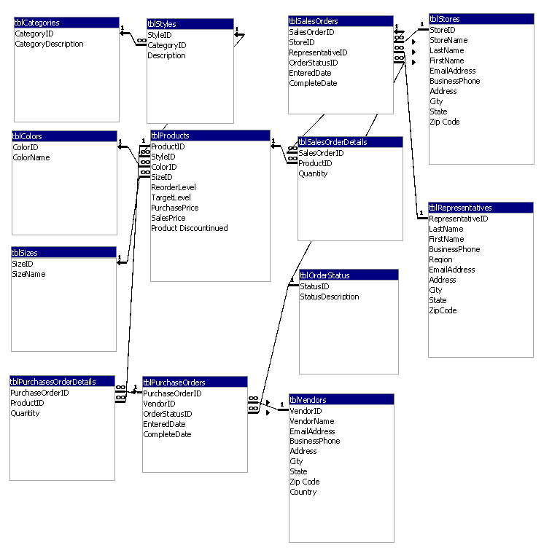

:

The primary and foreign keys are the following:

|  |  |  |
| --- | --- | --- |
| Entity | Primary Key | Foreign Key |
| tblProducts | ProductID | StyleID  ColorID  SizeID |
| tblColors | ColorID |  |
| tblSizes | SizeID |  |
| tblStyles | StylesID | CategoryID |
| tblCategories | CategoryID |  |
| tblSalesOrderDetails | SalesOrderID  ProductID |  |
| tblSalesOrders | SalesOrderID | RepresentativeID  OrderStatusID  StoreID |
| tblRepresentatives | RepresentativeID |  |
| tblPurchaseOrderDetails | PurchaseOrderID  ProductID |  |
| tblPurchaseOrders | PurchaseOrderID | VendorID  OrderStatusID |
| tblVendors | VendorID |  |
| tblOrdersStatus | OrderStatusID |  |
| tblStores | StoreID |  |

The functional dependencies determined were:

fd1: ProductID → StyleID, ColorID, SizeID, ReorderLevel, TargetLevel, Product Price, SalesPrice, Product Discountinued

PK = {ProductID}

FK1 = {StyleID} REF to tblStyles

FK2 = {ColorID} REF to tblColors

FK3 = {SizeID} REF to tblSizes

fd2: ColorID → ColorName

PK = {ColorID}

fd3: SizeID → SizeName

PK = {SizeID}

fd4: StylesID → CategoryID, Description

PK = {StyleID}

FK1 = {CategoryID} REF to tblCategories

fd5: CategoryID → CategoryDescritpion

PK = {CategoryID}

fd6: SalesOrderID, ProductID → Quantity

PK1 = {SalesOrderID} REF to tblSalesOrders

PK2 = {ProductID} REF to tblProducts

fd7: SalesOrderID → StoreID, RepresentativeID, OrderStatusID, EnteredDate, CompleteDate

PK = {SalesOrderID}

FK1 = {StoreID} REF to tblStores

FK2 = {RepresentativeID} REF to tblRepresentatives

FK3 = {OrderStatusID} REF to tblOrderStatus

fd8: RepresentativeID → LastName, FirstName, BusinessPhone, Region, EmailAddress, City, State, Zip Code

PK = {RepresentativeID}

fd9: PurchaseOrderID, ProductID → Quantity

PK1 = {PurchaseOrderID} REF to tblPurchaseOrders

PK2 = {ProductID} REF to tblProducts

fd10: PurchaseOrderID → VendorID, OrderStatusID, EnteredDate, CompleteDate

PK = {PurchaseOrderID}

FK1 = {VendorID} REF to tblVendors

FK2 = {OrderStatusID} REF to tblOrderStatus

fd11: VendorID → VendorName, EmailAddress, BusinessPhone, Address, City, State, Zip Code

PK = {VendorID}

fd12: StatusID → StatusDescription

PK = {StatusID}

fd13: StoreID → StoreName, LastName, FirstName, EmailAddress, BusinessPhone, Address, City, State, Zip Code,

**After this normalization was completed. To meet the requirements of first normal form:**

* The tables have no repeating fields or group of fields.

**All relations are in second normal form because:**

* All non-key fields depend on the value of primary key

**All relations are in third normal form because:**

* The non-key fields of the table be fully dependent on the value of the primary key and describe only the object that the table represents.

**Implementation in Access**

The next step of the project involved data preparation in Excel. Data for the database project were entered into an Excel spreadsheet, saved as cvs files and exported to the tables.

Once data was entered into the tables, the next step was to create a user interface. The following reports were created and their purpose is as follows:

**Open Sales Orders**: Are used to analyze orders from stores that have been placed by them but not yet completed by Valention Bugel.

**Open Purchase Orders:** Are used to analyze the purchases that have been placed but not yet received by Valentino Bugel.

**Product List:** Presents all items designed by Valentino Bugel that are available for sale.

**Representative List**: Presents information regarding representatives that cooperate with Valentino Bugel.

**Stores List:** Presents information regarding stores that purchase Valentino Bugel clothes.

The following forms were implemented and their purpose is as follows:

**Products:** Serve for entering new products, updating the present ones and deleting products from the database.

**Purchase Order:** Serve for entering new purchase orders, updating the present ones and deleting purchase orders from the database.

**Sales Order:** Serve for entering new sales orders, updating the present ones and deleting sales orders from the database.

**Representatives:** Serve for entering new representatives, updating the present ones and deleting representatives from the database.

**Stores:** Serve for entering new stores, updating the present ones an deleting sales orders from the database.

**Vendors:** Serve for entering new vendors, updating the present ones and deleting vendors from the database.

At the end the menu contains eleven buttons. Six for forms and five reports.

**Conclusion**

Overall this was for the whole team a very challenging project. From the technical point of view implementation of action queries for the interface turned out to be a problematic task as the team lacked experience with such kind of Access knowledge. Even from the organizational point of view the assignment was a new experience for all our members. It was difficult to plan and divide work in a fashion that would not hinder the time of the project completion. The project involved constant cooperation and certain disagreements that had to be overcome to complete the assignment. After all at the end the project opened our eyes to a practical use of database design knowledge.